**String Functions in SQL*Plus (Oracle) & MySQL**

String functions allow you to **manipulate and process text data** in SQL. Below is a detailed comparison of **SQL*Plus (Oracle)** and **MySQL** string functions, including examples.

**1. String Functions in SQL*Plus (Oracle)**

**1.1 CONCAT – String Concatenation**

SELECT CONCAT('Hello', ' World') FROM dual; -- Result: Hello World SELECT 'Hello' || ' World' FROM dual; -- Alternative method using ||

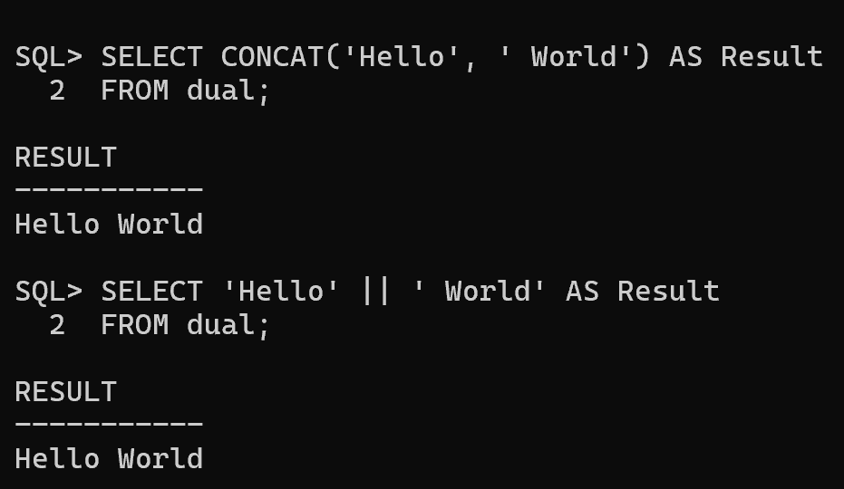

**1.2 LENGTH – String Length**

SELECT LENGTH('Oracle Database') FROM dual; -- Result: 16

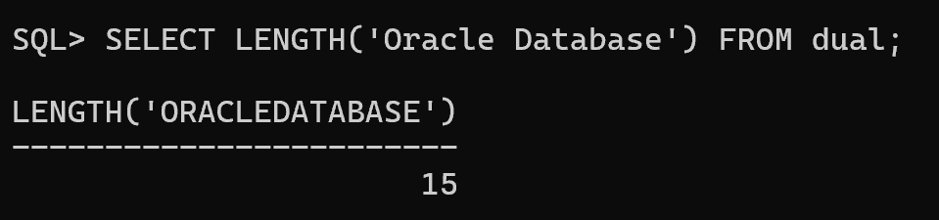

**1.3 SUBSTR – Extract Substring**

SELECT SUBSTR('Oracle Database', 8, 3) FROM dual; -- Extracts 'Dat' (Start from 8, length 3)

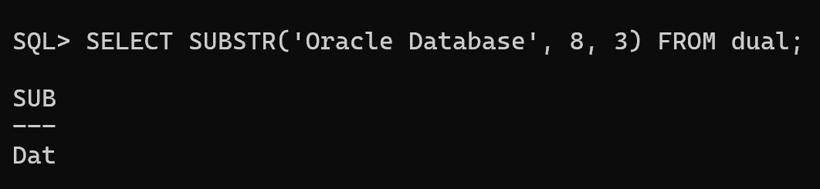

**1.4 INSTR – Find Position of a Substring**

SELECT INSTR('Oracle Database', 'D') FROM dual; -- Finds position of 'D' (Result: 8)

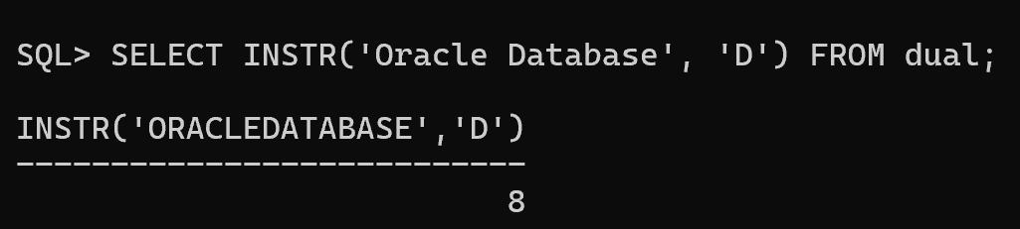

**1.5 REPLACE – Replace a Substring**

SELECT REPLACE('Oracle Database', 'Database', 'SQL') FROM dual; -- Result: Oracle SQL

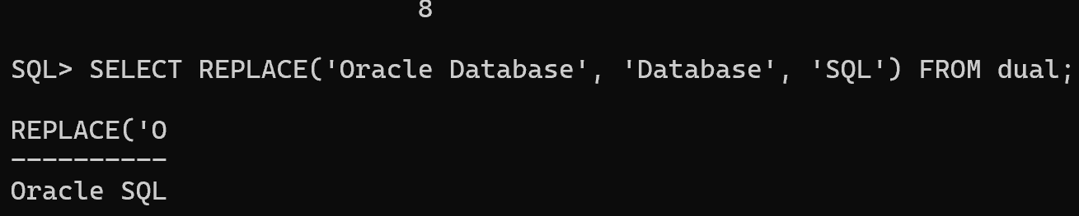

**1.6 TRANSLATE – Replace Multiple Characters**

SELECT TRANSLATE('123-456-7890', '123', 'XYZ') FROM dual; -- Result: XYZ-456-7890 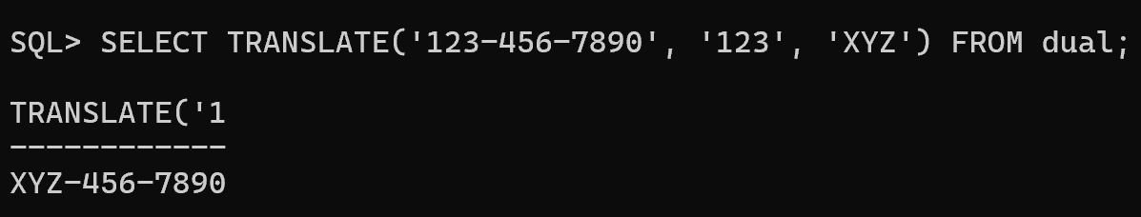

**1.7 TRIM – Remove Spaces or Characters**

SELECT TRIM(' Oracle ') FROM dual; -- Removes leading and trailing spaces 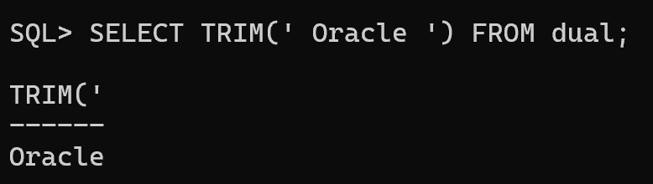

SELECT TRIM('O' FROM 'Oracle') FROM dual; -- Removes 'O' from both ends 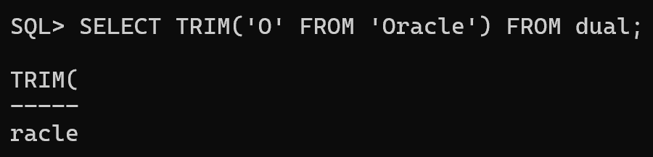

**1.8 LPAD & RPAD – Padding Strings**

SELECT LPAD('Oracle', 10, '*') FROM dual; -- Result: ****Oracle SELECT RPAD('Oracle', 10, '*') FROM dual; -- Result: Oracle****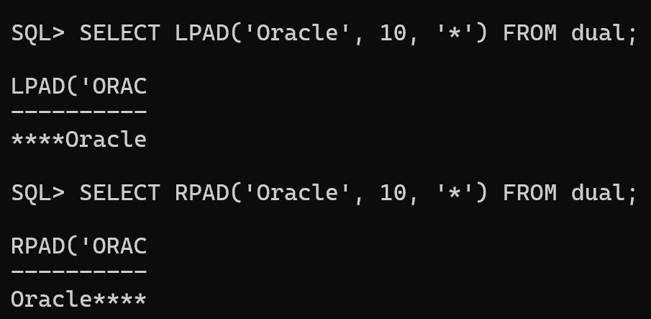

**1.9 LOWER, UPPER, INITCAP – Case Conversion**

SELECT LOWER('Oracle Database') FROM dual; -- Result: oracle database SELECT UPPER('Oracle Database') FROM dual; -- Result: ORACLE DATABASE SELECT INITCAP('oracle database') FROM dual; -- Result: Oracle Database 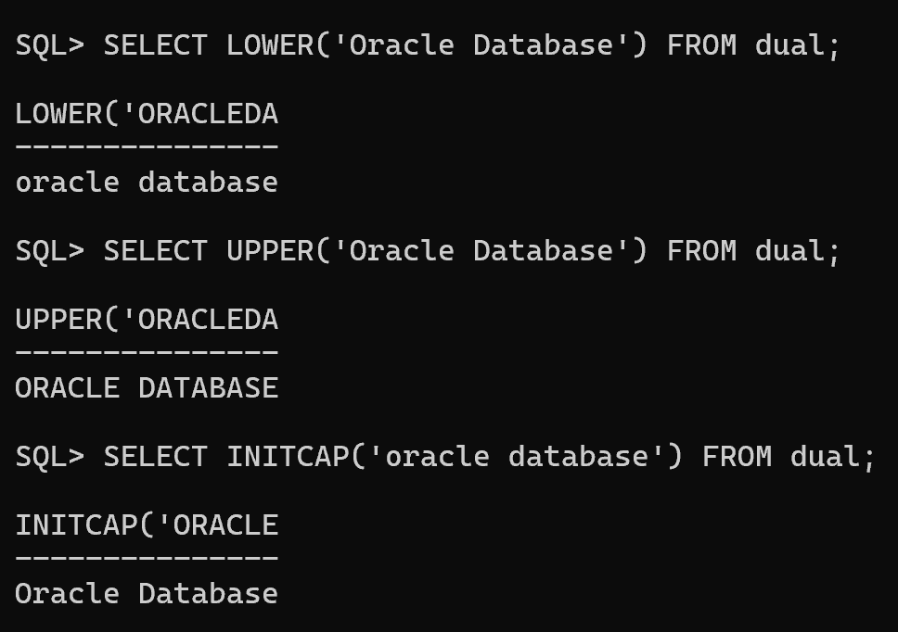

**1.10 REGEXP Functions – Regular Expressions**

SELECT REGEXP_SUBSTR('A123B456C', '[0-9]+') FROM dual; -- Extracts first number (Result: 123)

SELECT REGEXP_REPLACE('abc123xyz', '[0-9]', '*') FROM dual; -- Replaces digits with '*' (Result: abc***xyz) 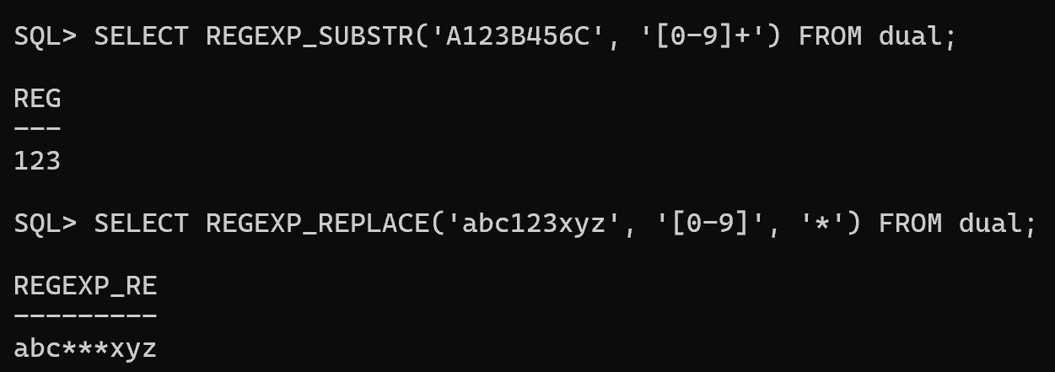

**2. String Functions in MySQL**

**2.1 CONCAT – String Concatenation**

SELECT CONCAT('Hello', ' World'); -- Result: Hello World 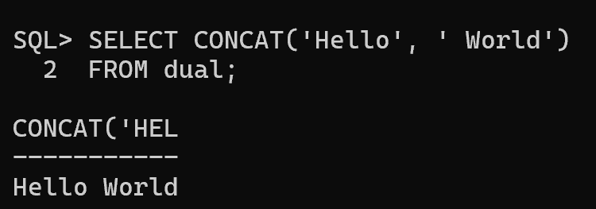

**2.2 LENGTH – String Length**

SELECT LENGTH('MySQL Database'); -- Result: 15

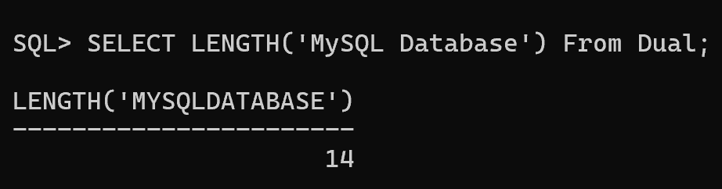

**2.3 SUBSTRING – Extract Substring**

SELECT SUBSTRING('MySQL Database', 8, 3); -- Extracts 'Dat' (Start from 8, length 3) 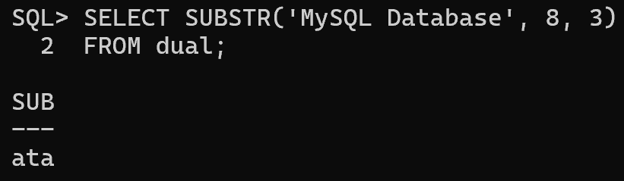

**2.4 LOCATE & INSTR – Find Position of a Substring**

SELECT LOCATE('D', 'MySQL Database'); -- Result: 8 SELECT INSTR('MySQL Database', 'D'); -- Result: 8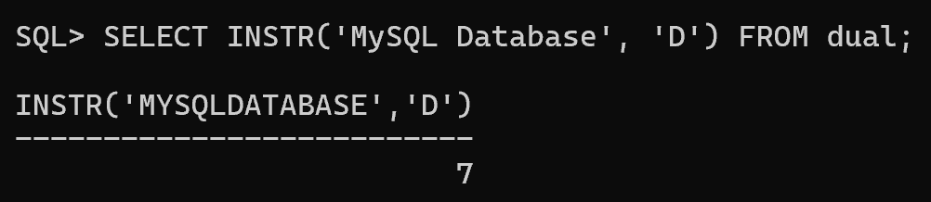

**2.5 REPLACE – Replace a Substring**

SELECT REPLACE('MySQL Database', 'Database', 'Server'); -- Result: MySQL Server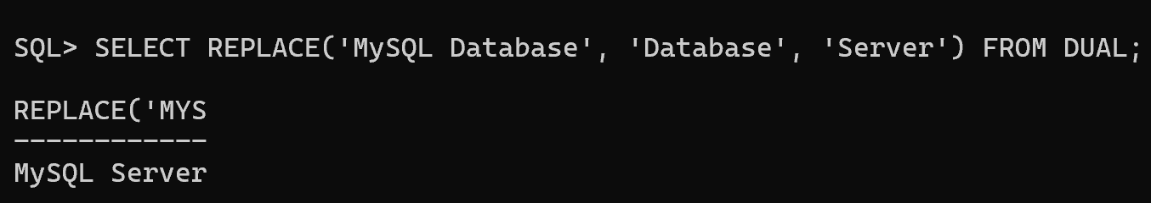

**2.6 TRIM – Remove Spaces or Characters**

SELECT TRIM(' MySQL '); -- Removes leading and trailing spaces SELECT TRIM('M' FROM 'MySQL'); -- Removes 'M' from both ends 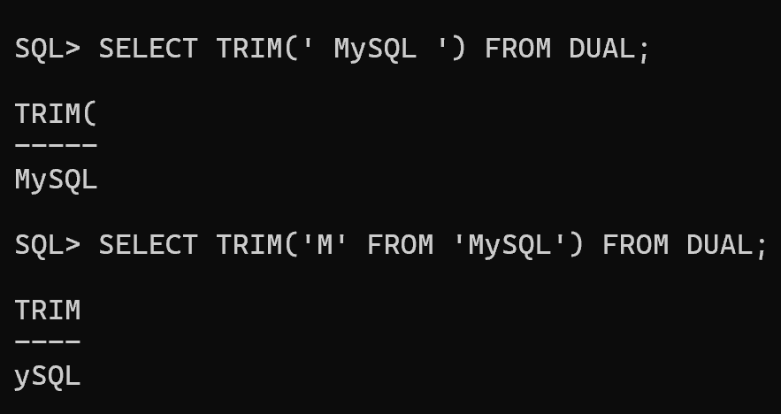

**2.7 LPAD & RPAD – Padding Strings**

SELECT LPAD('MySQL', 10, '*'); -- Result: *****MySQL

SELECT RPAD('MySQL', 10, '*'); -- Result: MySQL*****

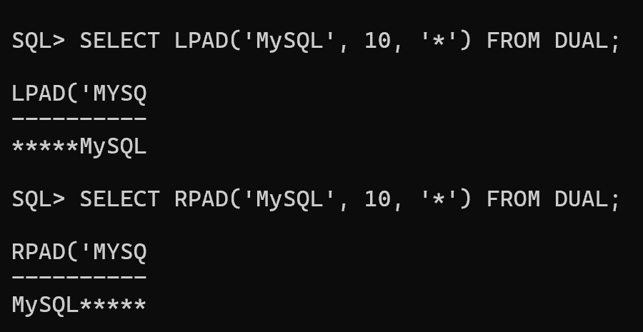

**2.8 LOWER, UPPER – Case Conversion**

SELECT LOWER('MySQL Database'); -- Result: my database SELECT UPPER('MySQL Database'); -- Result: MYSQL DATABASE 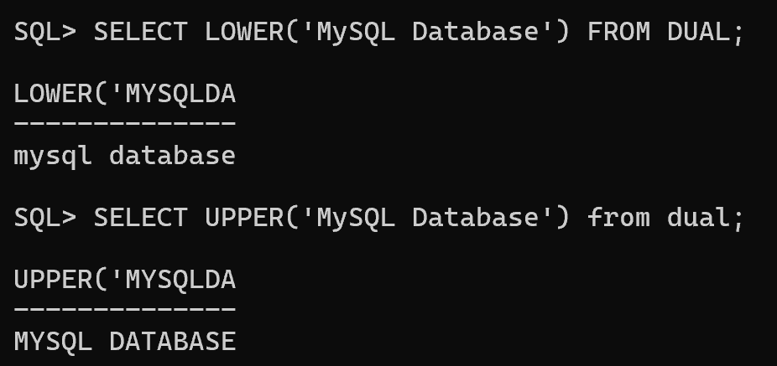

**2.9 REGEXP Functions – Regular Expressions**

SELECT REGEXP_SUBSTR('abc123xyz', '[0-9]+'); -- Extracts first number (Result: 123)

SELECT REGEXP_REPLACE('abc123xyz', '[0-9]', '*'); -- Replaces digits with '*' (Result: abc***xyz) 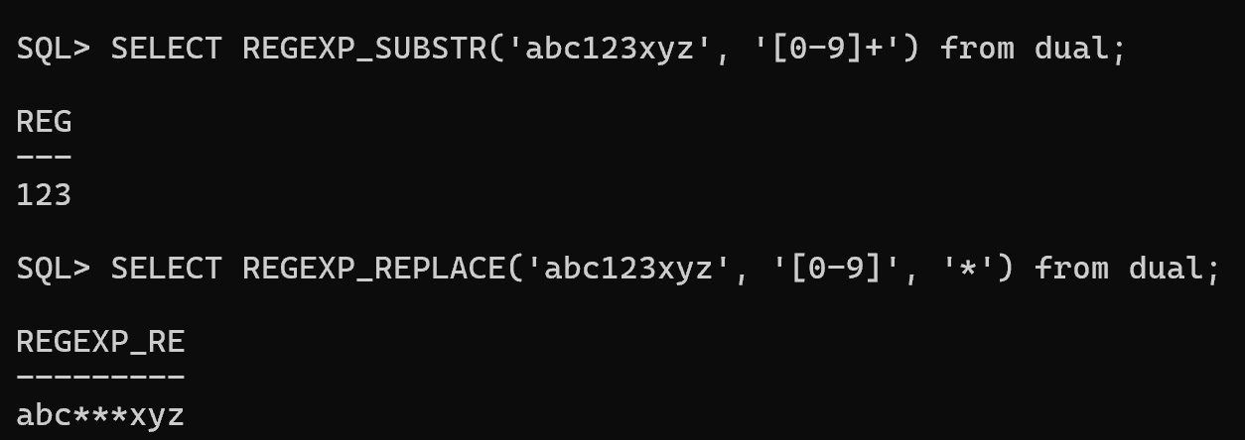

**3. Key Differences Between SQL*Plus (Oracle) and MySQL String Functions**

|  |  |  |
| --- | --- | --- |
| **Function** | **Oracle (SQL*Plus)** | **MySQL** |

|  |  |  |
| --- | --- | --- |
| Concatenation | CONCAT(str1, str2) or `' |  |
| Substring | SUBSTR(str, start, length) | SUBSTRING(str, start,  length) |
| Find Position | INSTR(str, substring) | LOCATE(substring, str) or INSTR(str, substring) |
| Replace  Substring | REPLACE(str, old, new) | REPLACE(str, old, new) |
| Trim Spaces | TRIM(str) | TRIM(str) |
| Padding | LPAD(str, length,  pad_char), RPAD(str,  length, pad_char) | LPAD(str, length,  pad_char), RPAD(str, length, pad_char) |
| Case  Conversion | UPPER(str), LOWER(str), INITCAP(str) | UPPER(str), LOWER(str) |
| Regular  Expressions | REGEXP_SUBSTR(),  REGEXP_REPLACE() | REGEXP_SUBSTR(),  REGEXP_REPLACE() |

**4. Special Notes**

● Oracle has **INITCAP()**, which capitalizes the first letter of each word, whereas MySQL does **not**.

● **CONCAT()** in Oracle only takes **two** arguments, while in MySQL it can take **multiple**. ● Regular expressions (REGEXP_...) are available in both, but Oracle has more advanced capabilities.